Cylinder-Based Composite Solids Formed by Addition

Definition
# Source: AI Source: Provided by: [Data Path: Persons Table -> ID Column: 1, Name_En Column: Motasem Essam] -> From: [ChatGPT] on [7/25/2026]
Cylinder-based composite solids are three-dimensional geometric objects formed by joining two or more cylinders or combining cylinders with other geometric solids to create a single composite structure.
The cylindrical components may have identical or different radii, heights, and orientations. They can be connected through their circular bases, curved lateral surfaces, or other suitable contact regions.
These structures may contain one or more cylindrical sections arranged vertically, horizontally, concentrically, or in other spatial configurations.
Examples include:
- Two cylinders joined end to end.
- Two cylinders stacked vertically.
- A large cylinder with a smaller cylindrical extension.
- Multiple cylinders arranged around a central cylinder.
- A cylinder combined with a rectangular prism.
- A cylinder combined with a cone or hemisphere.

Simple Definition
# Source: AI Source: Provided by: [Data Path: Persons Table -> ID Column: 1, Name_En Column: Motasem Essam] -> From: [ChatGPT] on [7/25/2026]
A cylinder-based composite solid is a 3D shape formed by joining two or more cylindrical components or combining cylinders with other geometric solids.
Its total volume is calculated by adding the component volumes, while its external surface area includes only the exposed surfaces.

Geometric Representation
# Source: AI Source: Provided by: [Data Path: Persons Table -> ID Column: 1, Name_En Column: Motasem Essam] -> From: [ChatGPT] on [7/25/2026]
A cylinder-based composite solid may consist of several geometric elements:
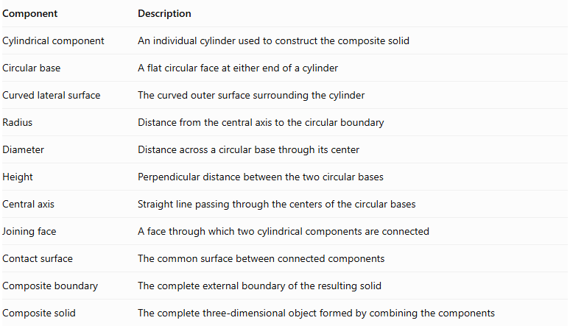
Component | Description
Cylindrical component | An individual cylinder used to construct the composite solid
Circular base | A flat circular face at either end of a cylinder
Curved lateral surface | The curved outer surface surrounding the cylinder
Radius | Distance from the central axis to the circular boundary
Diameter | Distance across a circular base through its center
Height | Perpendicular distance between the two circular bases
Central axis | Straight line passing through the centers of the circular bases
Joining face | A face through which two cylindrical components are connected
Contact surface | The common surface between connected components
Composite boundary | The complete external boundary of the resulting solid
Composite solid | The complete three-dimensional object formed by combining the components

Types of Cylinder-Based Composite Solids
# Source: AI Source: Provided by: [Data Path: Persons Table -> ID Column: 1, Name_En Column: Motasem Essam] -> From: [ChatGPT] on [7/25/2026]
These solids can be classified according to the arrangement and configuration of their cylindrical components.

Coaxial Cylinder-Based Composite Solids
# Source: AI Source: Provided by: [Data Path: Persons Table -> ID Column: 1, Name_En Column: Motasem Essam] -> From: [ChatGPT] on [7/25/2026]
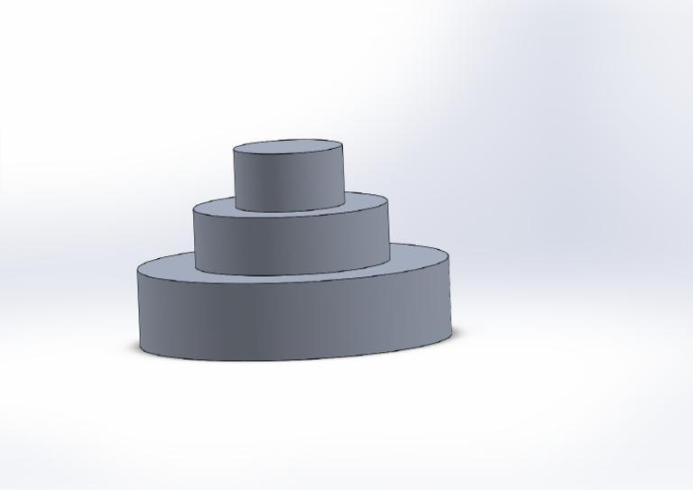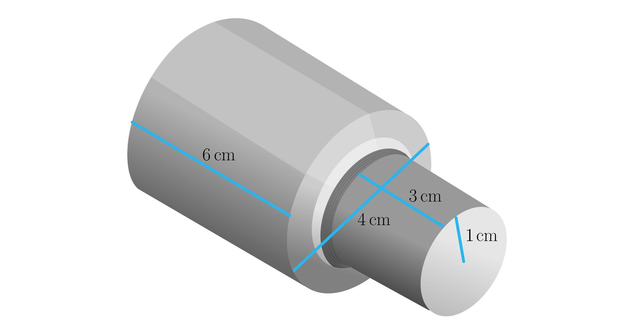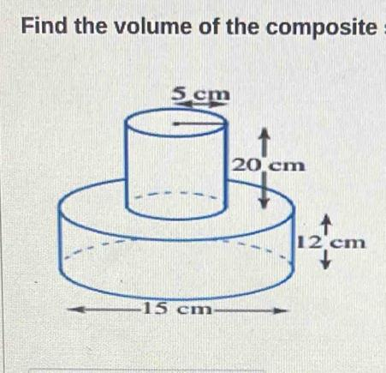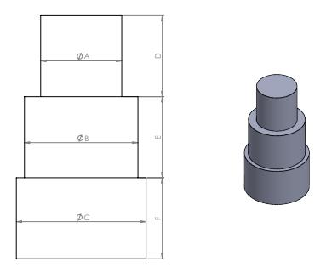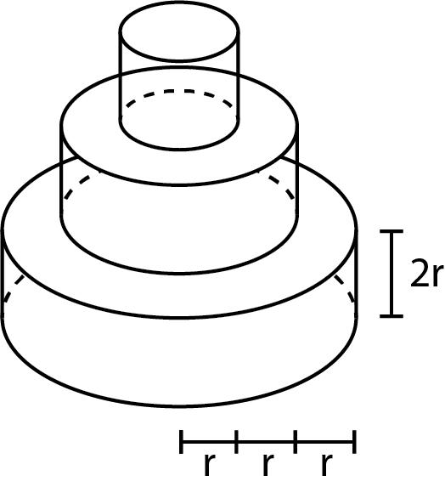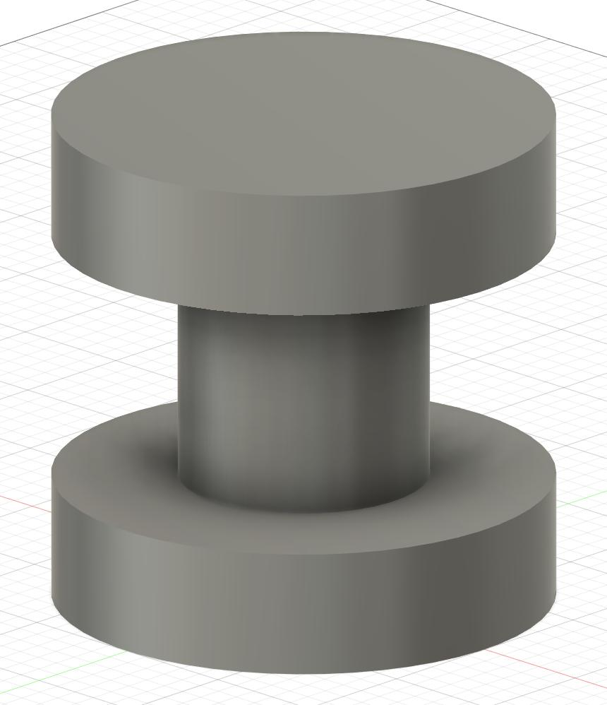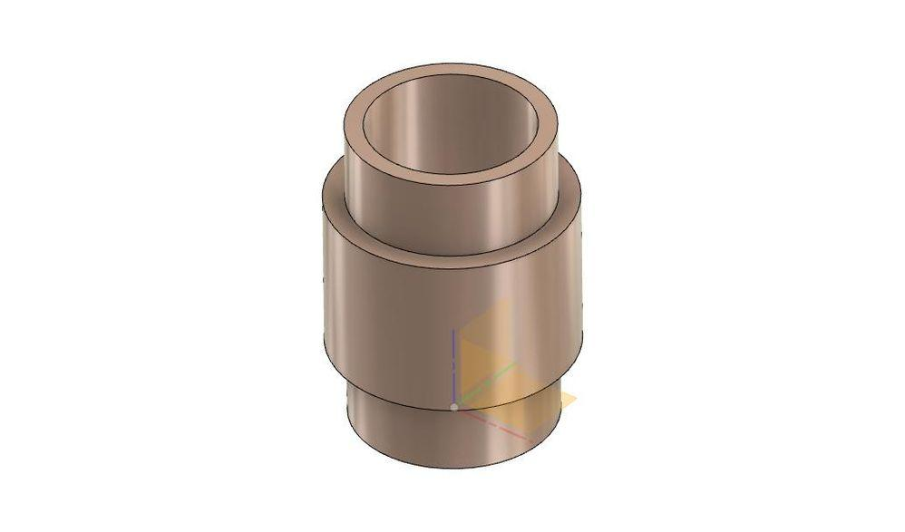
Created by joining two or more cylinders along a common central axis.
Examples:
- Two coaxial cylinders with different radii.
- Two coaxial cylinders with different heights.
- Three or more coaxial cylinders forming a stepped cylindrical solid.
- Large cylinder with a smaller coaxial cylindrical extension.
- Multiple cylindrical sections arranged along the same central axis.

Stacked Cylinder-Based Composite Solids
# Source: AI Source: Provided by: [Data Path: Persons Table -> ID Column: 1, Name_En Column: Motasem Essam] -> From: [ChatGPT] on [7/25/2026]
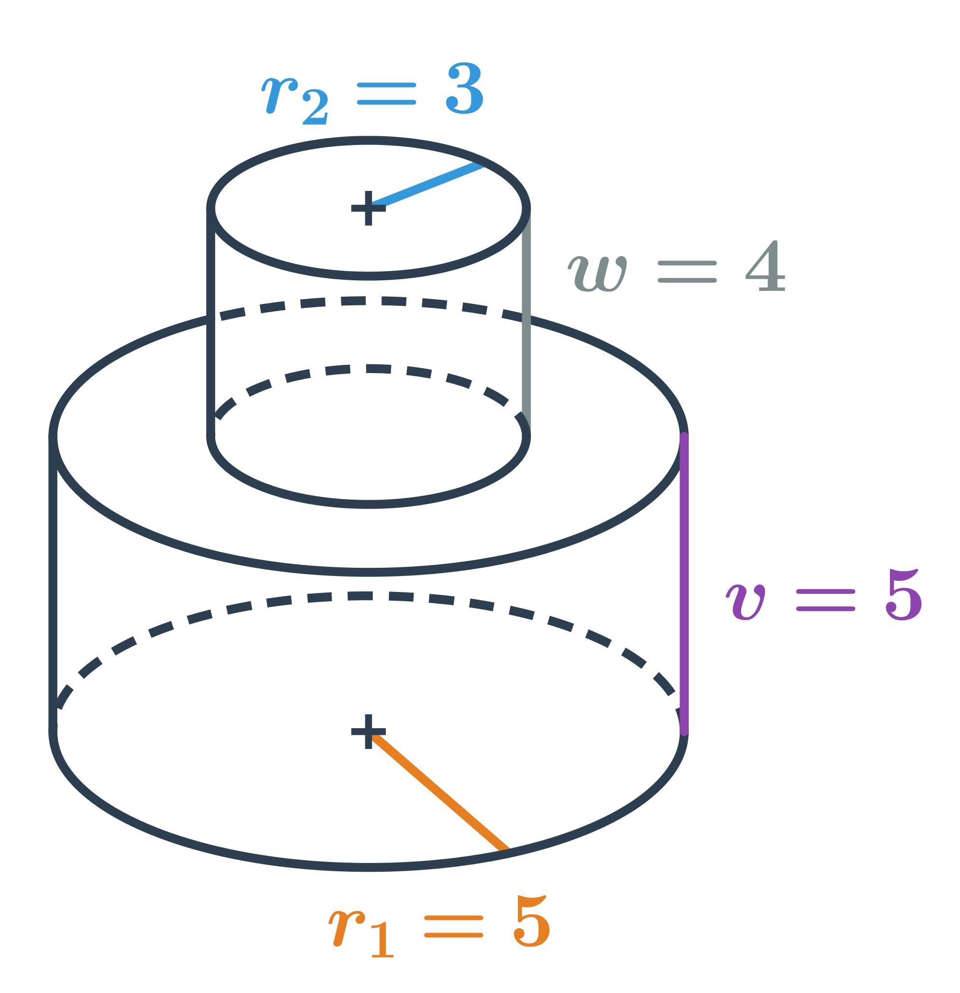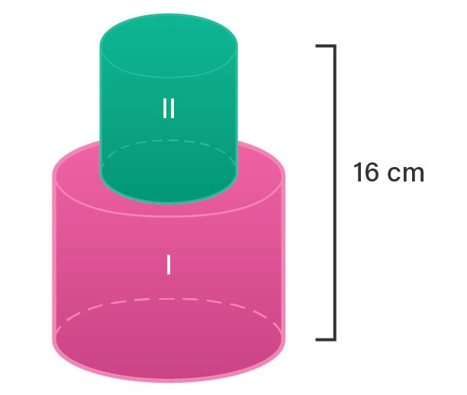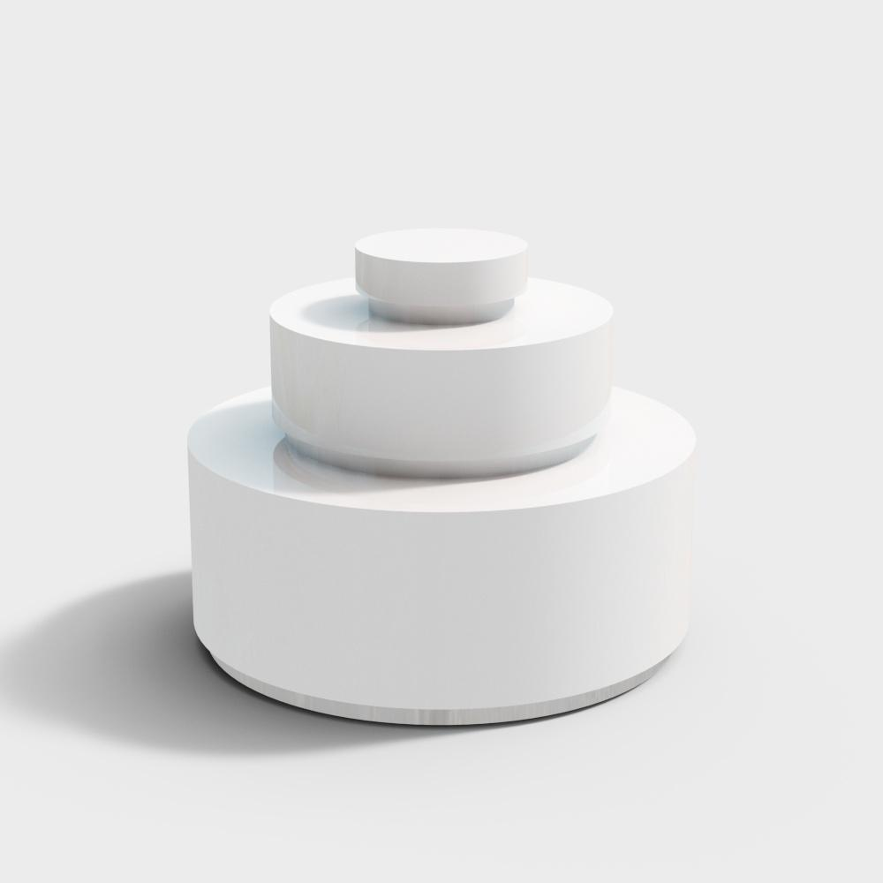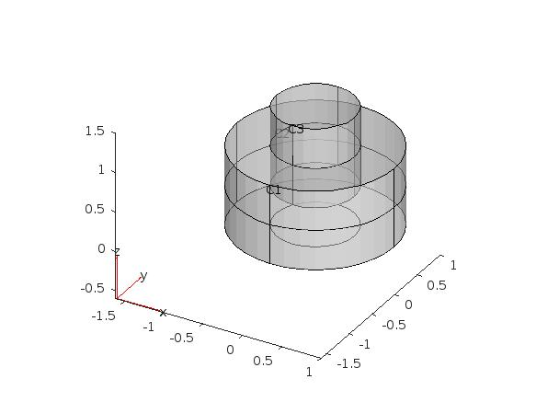
Created by placing multiple cylindrical components one above another, with their circular bases joined.
Examples:
- Two identical cylinders stacked vertically.
- Two cylinders with different radii stacked vertically.
- Multiple cylindrical sections stacked in decreasing diameter.
- Multiple cylindrical sections stacked in increasing diameter.
- Stepped cylindrical column formed by stacking cylinders.

End-to-End Cylinder-Based Composite Solids
# Source: AI Source: Provided by: [Data Path: Persons Table -> ID Column: 1, Name_En Column: Motasem Essam] -> From: [ChatGPT] on [7/25/2026]
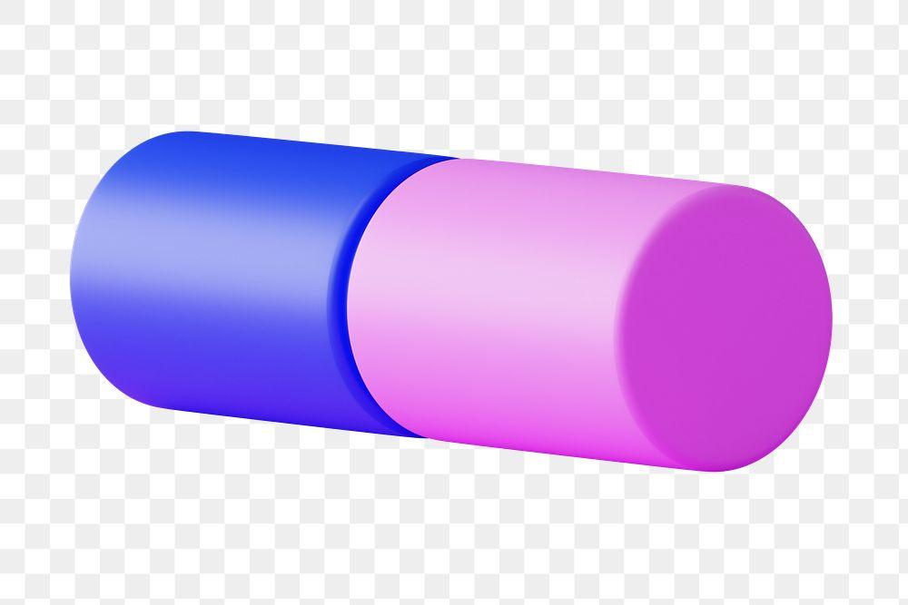
Created by joining cylinders through their circular bases to extend the overall length of the structure.
Examples:
- Two identical cylinders joined end to end.
- Two cylinders with different radii joined end to end.
- Multiple cylindrical sections connected along a straight axis.
- Long cylindrical structure formed from several sections.
- Composite cylinder with alternating large and small diameters.

Side-by-Side Cylinder-Based Composite Solids
# Source: AI Source: Provided by: [Data Path: Persons Table -> ID Column: 1, Name_En Column: Motasem Essam] -> From: [ChatGPT] on [7/25/2026]
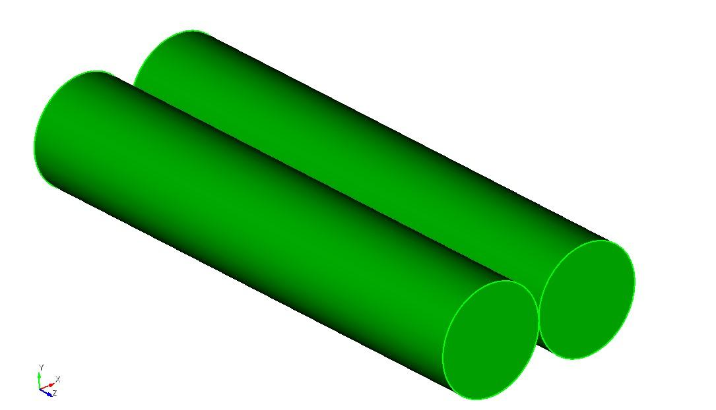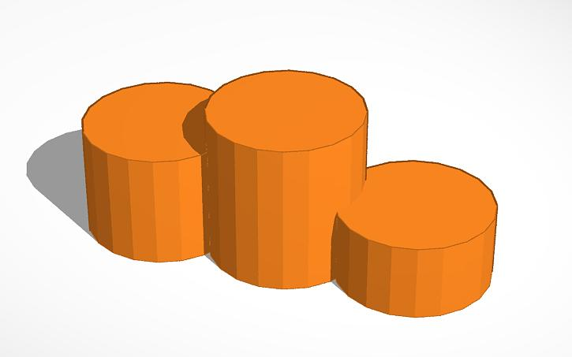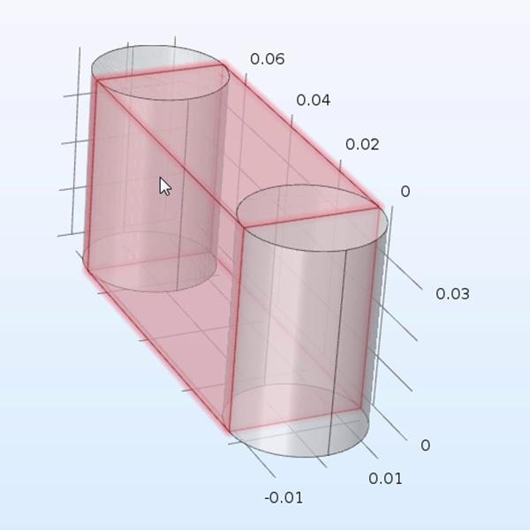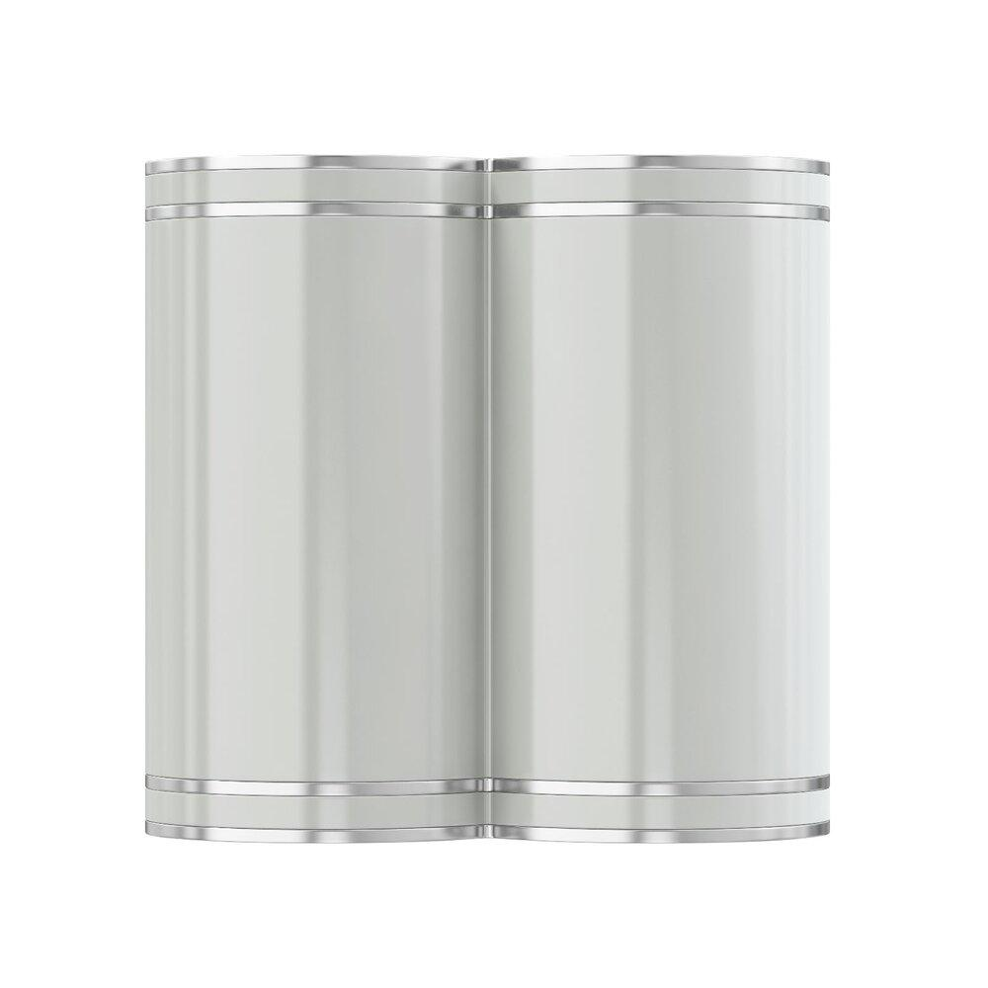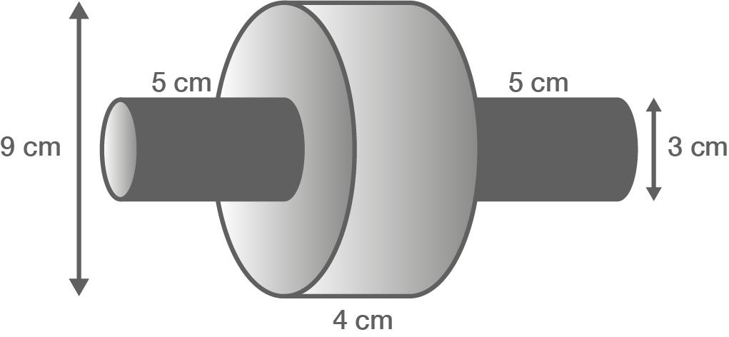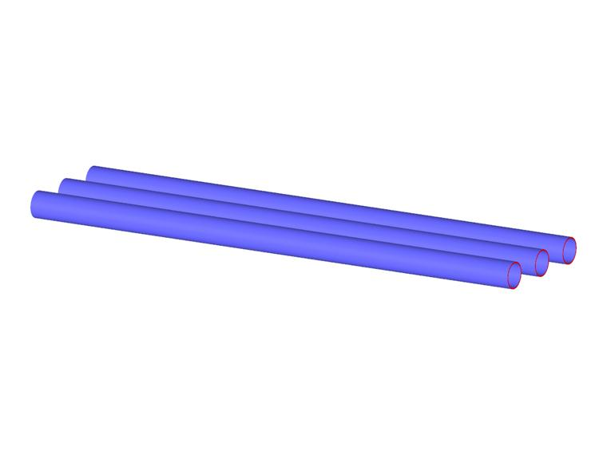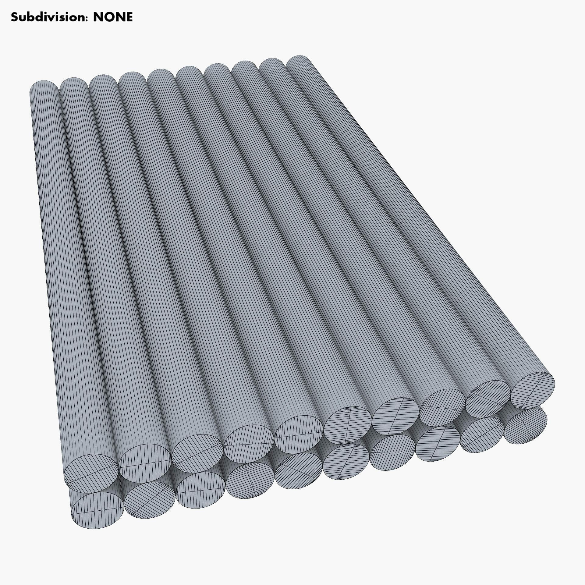
Created by arranging multiple cylindrical components parallel to one another in a side-by-side configuration.
Examples:
- Two parallel cylinders joined along their lateral regions.
- Three identical cylinders arranged side by side.
- Multiple cylinders arranged in a straight row.
- Cylindrical components arranged in parallel rows.
- Composite cylindrical structure formed by multiple parallel sections.

Radial Cylinder-Based Composite Solids
# Source: AI Source: Provided by: [Data Path: Persons Table -> ID Column: 1, Name_En Column: Motasem Essam] -> From: [ChatGPT] on [7/25/2026]
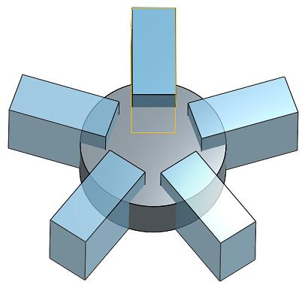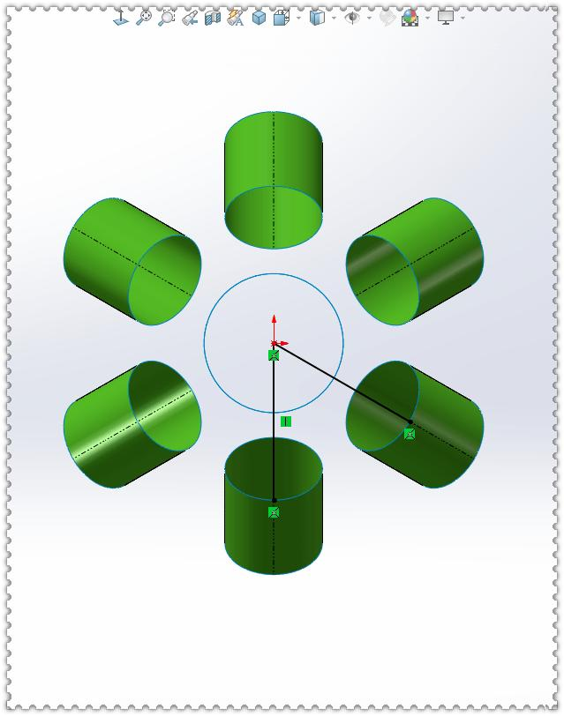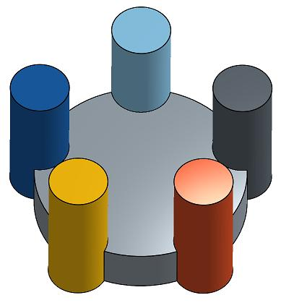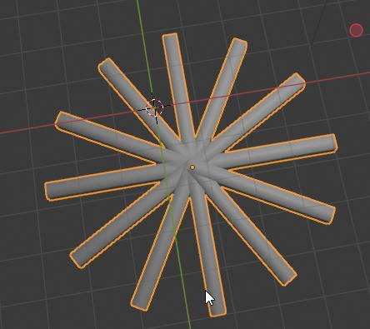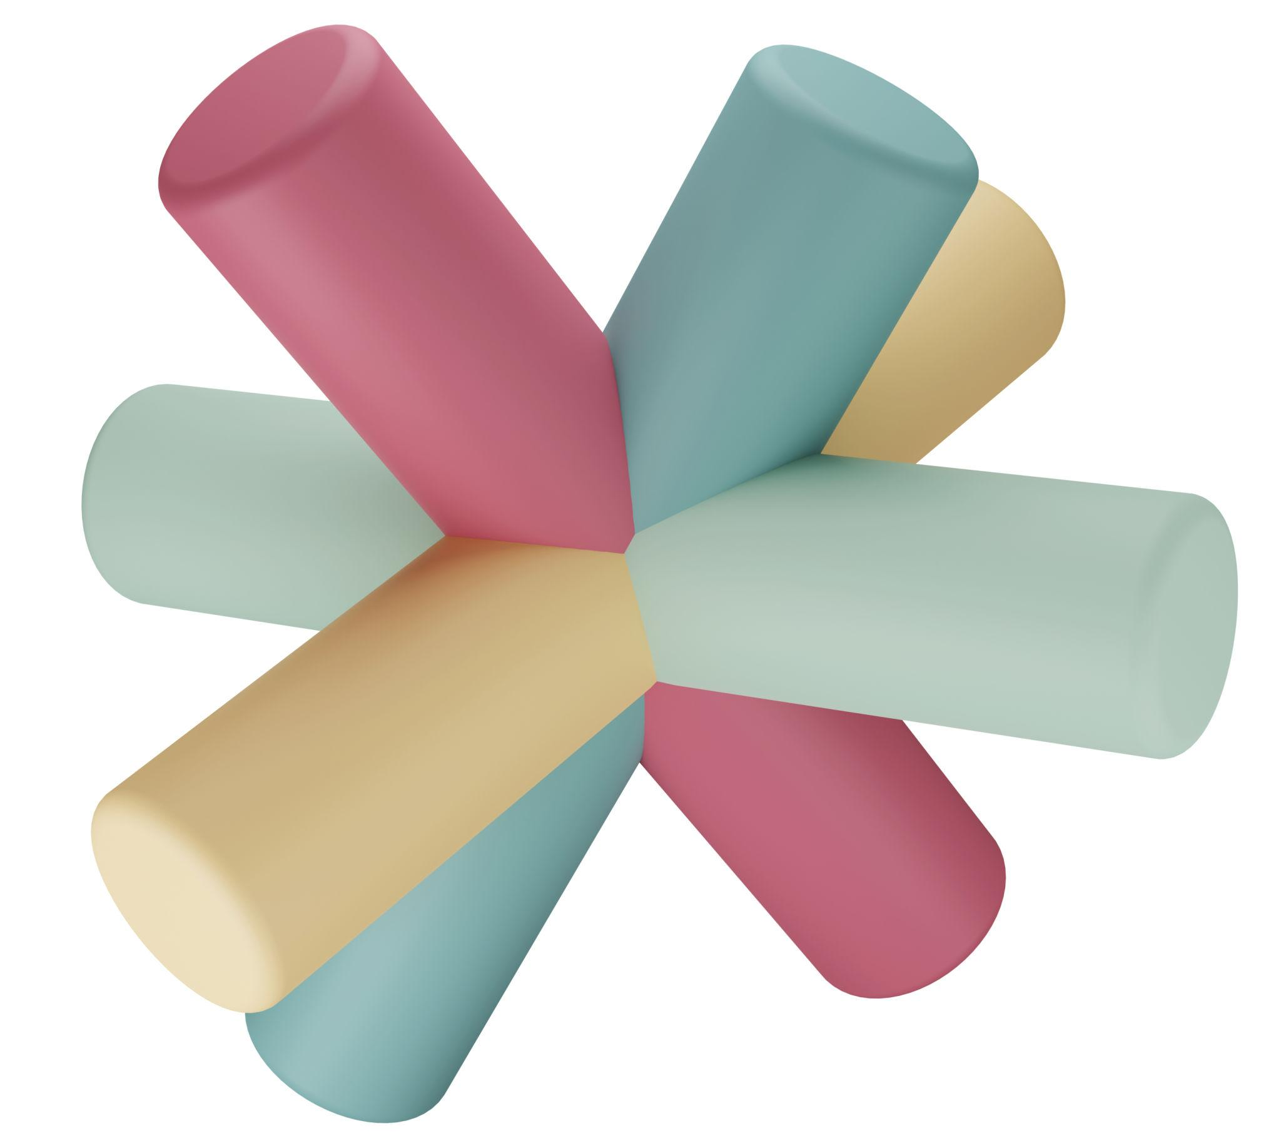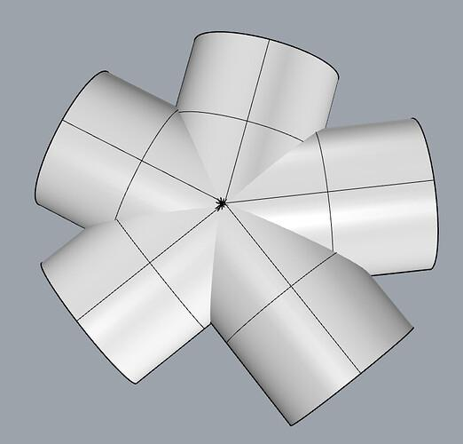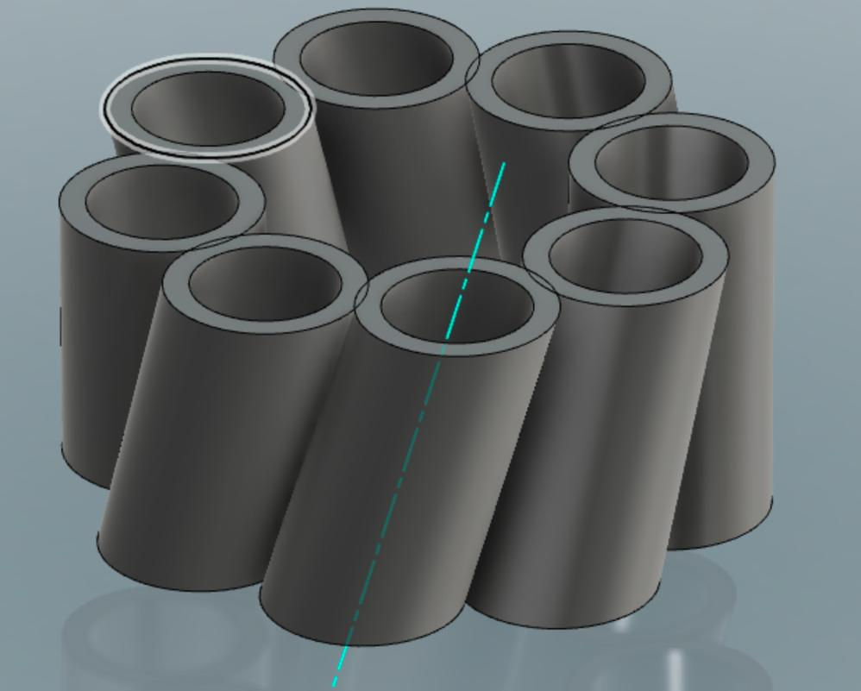
Created by arranging multiple cylindrical components around a central point or axis.
Examples:
- Multiple cylinders arranged around a central cylinder.
- Four cylindrical components arranged symmetrically around a central axis.
- Radial arrangement of identical cylindrical sections.
- Composite structure formed by cylinders extending outward from a central cylindrical component.
- Circular arrangement of cylindrical components.

Intersecting Cylinder-Based Composite Solids
# Source: AI Source: Provided by: [Data Path: Persons Table -> ID Column: 1, Name_En Column: Motasem Essam] -> From: [ChatGPT] on [7/25/2026]
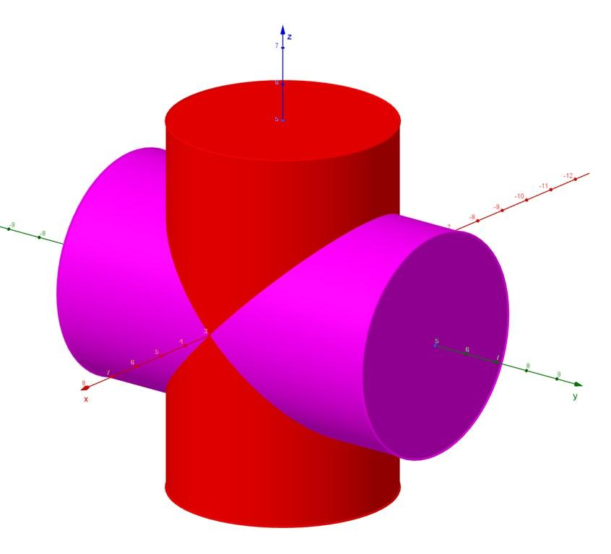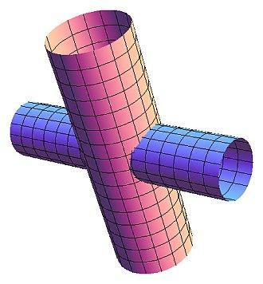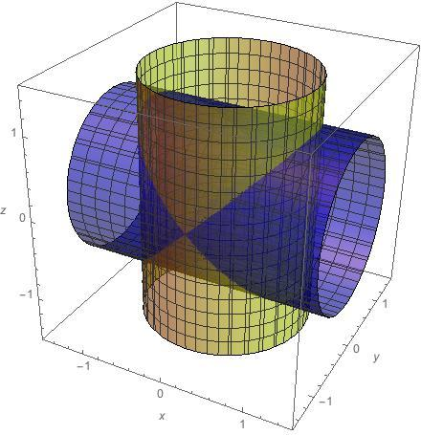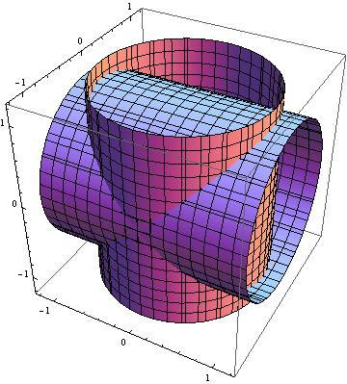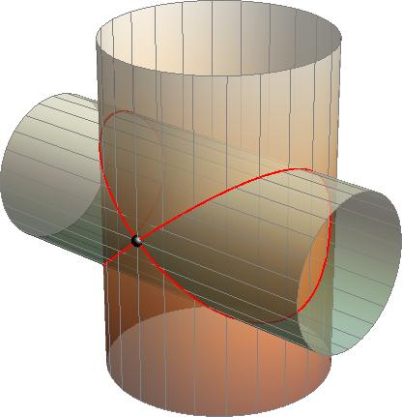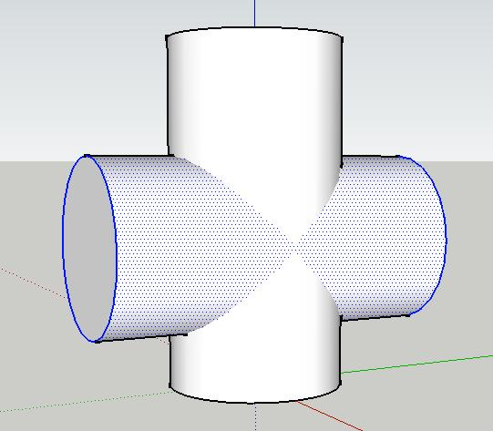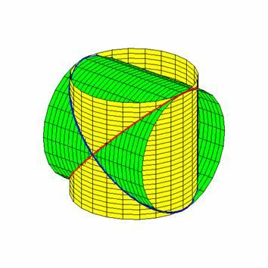
Created by joining cylindrical components whose central axes intersect or cross at different angles.
Examples:
- Two perpendicular cylinders forming a cross-shaped structure.
- Two cylinders intersecting at an oblique angle.
- Three cylinders intersecting at a common region.
- Horizontal cylinder joined to a vertical cylinder.
- Multiple intersecting cylindrical sections.

Mixed-Shape Cylinder-Based Composite Solids
# Source: AI Source: Provided by: [Data Path: Persons Table -> ID Column: 1, Name_En Column: Motasem Essam] -> From: [ChatGPT] on [7/25/2026]
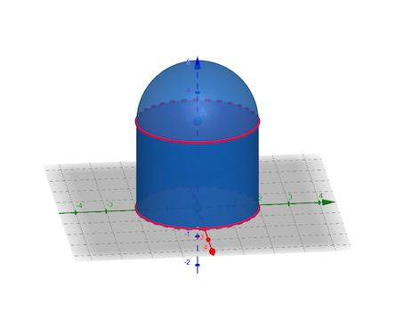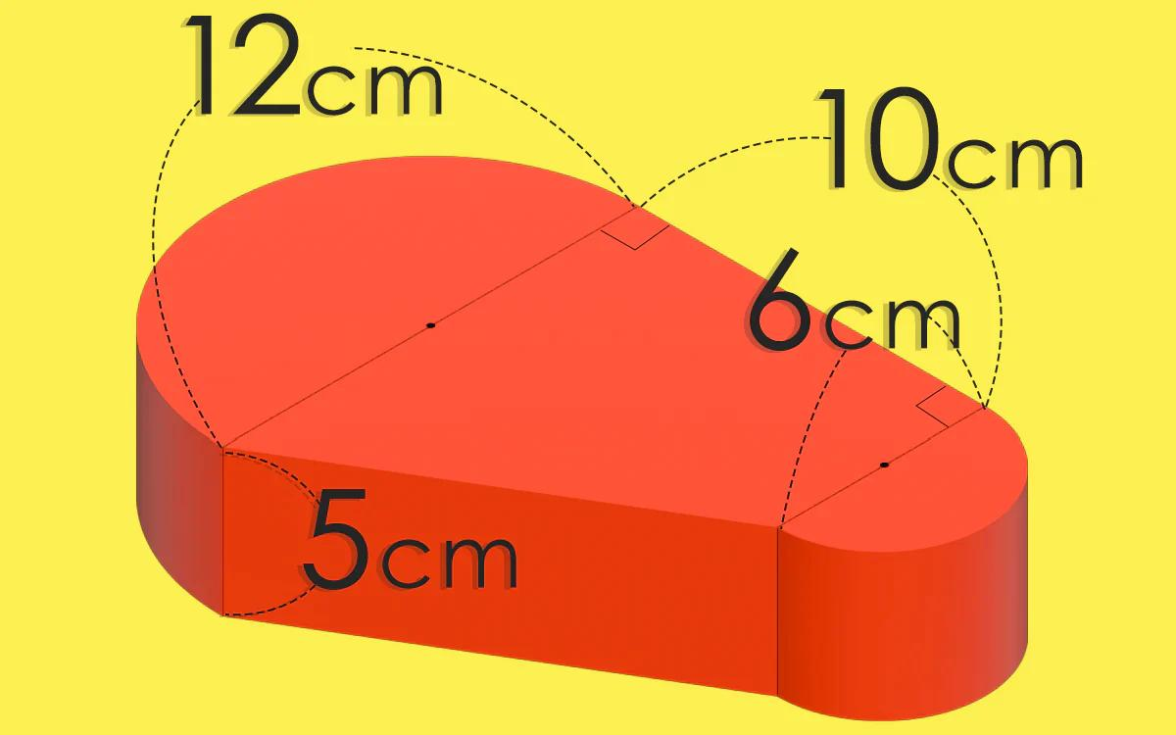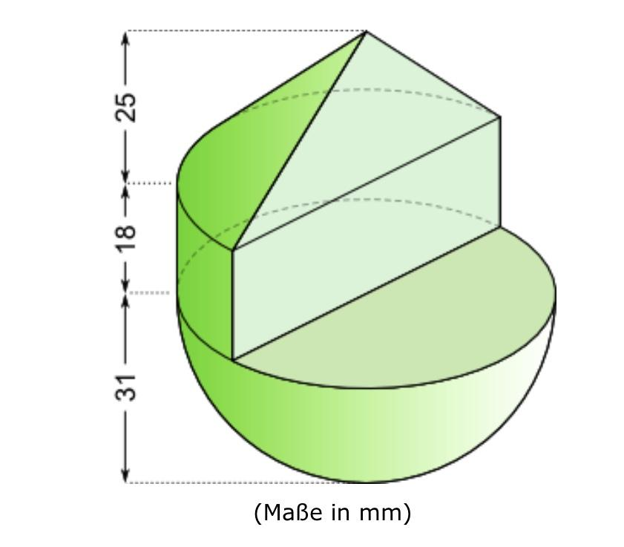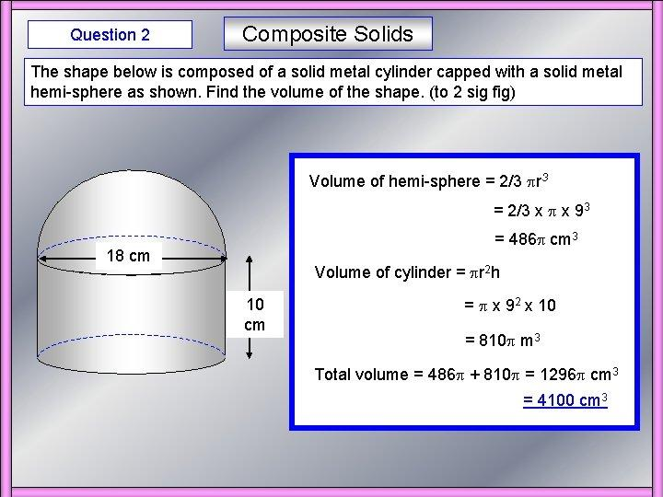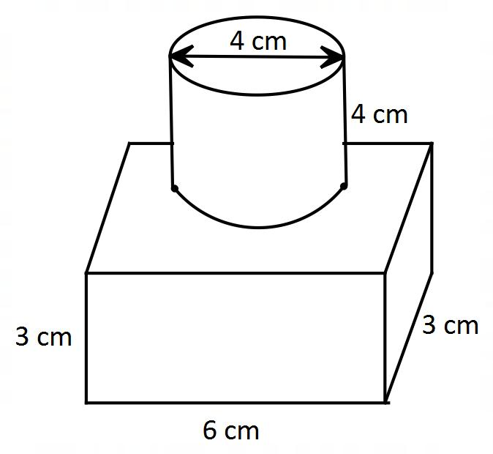
Created by combining one or more cylindrical components with other geometric solids.
Examples:
- Cylinder combined with a rectangular prism.
- Cylinder combined with a triangular prism.
- Cylinder combined with a cone.
- Cylinder combined with a hemisphere.
- Cylinder combined with a sphere.
- Multiple cylinders combined with prisms and cones.

Classification by Component Arrangement
# Source: AI Source: Provided by: [Data Path: Persons Table -> ID Column: 1, Name_En Column: Motasem Essam] -> From: [ChatGPT] on [7/25/2026]
Cylinder-based composite solids can also be classified according to how their cylindrical components are positioned and connected.
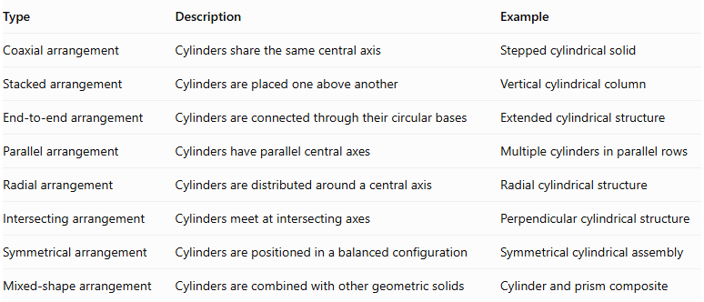
Type | Description | Example
Coaxial arrangement | Cylinders share the same central axis | Stepped cylindrical solid
Stacked arrangement | Cylinders are placed one above another | Vertical cylindrical column
End-to-end arrangement | Cylinders are connected through their circular bases | Extended cylindrical structure
Parallel arrangement | Cylinders have parallel central axes | Multiple cylinders in parallel rows
Radial arrangement | Cylinders are distributed around a central axis | Radial cylindrical structure
Intersecting arrangement | Cylinders meet at intersecting axes | Perpendicular cylindrical structure
Symmetrical arrangement | Cylinders are positioned in a balanced configuration | Symmetrical cylindrical assembly
Mixed-shape arrangement | Cylinders are combined with other geometric solids | Cylinder and prism composite

Classification by Component Dimensions
# Source: AI Source: Provided by: [Data Path: Persons Table -> ID Column: 1, Name_En Column: Motasem Essam] -> From: [ChatGPT] on [7/25/2026]
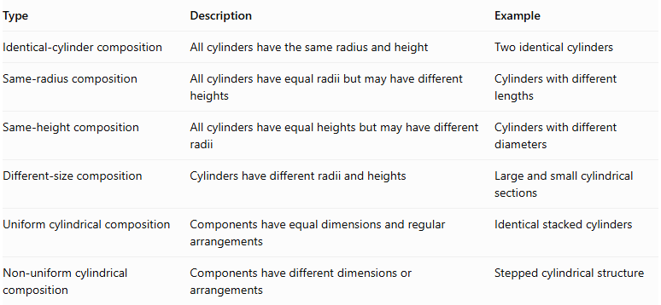
Type | Description | Example
Identical-cylinder composition | All cylinders have the same radius and height | Two identical cylinders
Same-radius composition | All cylinders have equal radii but may have different heights | Cylinders with different lengths
Same-height composition | All cylinders have equal heights but may have different radii | Cylinders with different diameters
Different-size composition | Cylinders have different radii and heights | Large and small cylindrical sections
Uniform cylindrical composition | Components have equal dimensions and regular arrangements | Identical stacked cylinders
Non-uniform cylindrical composition | Components have different dimensions or arrangements | Stepped cylindrical structure

Mathematical Properties and Formulas

Total Volume
# Source: AI Source: Provided by: [Data Path: Persons Table -> ID Column: 1, Name_En Column: Motasem Essam] -> From: [ChatGPT] on [7/25/2026]
The volume of a cylinder-based composite solid is calculated by adding the volumes of its cylindrical components.
For two cylinders:
$$\boxed{V_{total}=V_{1}+V_{2}}$$
For multiple non-overlapping cylinders:
$$\boxed{V_{total}=\sum_{i=1}^{n}{V_{i}}}$$
Where:
- $V_{total}$: Total volume of the composite solid.
- $V_{i}$: Volume of each cylindrical component.
- $n$: Number of cylindrical components.

Volume of a Cylinder
# Source: AI Source: Provided by: [Data Path: Persons Table -> ID Column: 1, Name_En Column: Motasem Essam] -> From: [ChatGPT] on [7/25/2026]
$$\boxed{V=πr^{2}h}$$
Where:
- $r$: Radius of the circular base.
- $h$: Perpendicular height of the cylinder.
For $n$ identical cylinders:
$$\boxed{V_{total}=nπr^{2}h}$$

External Surface Area
# Source: AI Source: Provided by: [Data Path: Persons Table -> ID Column: 1, Name_En Column: Motasem Essam] -> From: [ChatGPT] on [7/25/2026]
The external surface area is the total area of all exposed surfaces of the composite cylindrical solid.
For two cylinders joined along a circular contact face:
$$\boxed{{SA}_{total}={SA}_{1}+{SA}_{2}-2A_{contact}}$$
Where:
- ${SA}_{1}$: Total surface area of the first cylinder.
- ${SA}_{2}$: Total surface area of the second cylinder.
- $A_{contact}$: Area of their common circular joining face.
For a complete cylinder:
$$SA=2πr^{2}+2πrh$$
Where:
- $2πr^{2}$: Area of the two circular bases.
- $2πrh$: Curved lateral surface area.
Important: Internal contact surfaces must be excluded from the external surface area. For intersecting cylinders or more complex arrangements, the exposed surfaces must be determined from the actual geometry of the union.

Worked Examples

Example 1: Two Coaxial Cylinders with Different Radii
# Source: AI Source: Provided by: [Data Path: Persons Table -> ID Column: 1, Name_En Column: Motasem Essam] -> From: [ChatGPT] on [7/25/2026]
A composite solid consists of two cylinders stacked vertically along the same central axis. The upper cylinder has a smaller radius than the lower cylinder.
Given:
First cylinder:
- Radius: $r_{1}=3 cm$
- Height: $h_{1}=6 cm$
Second cylinder:
- Radius: $r_{2}=2 cm$
- Height: $h_{2}=4 cm$
Step 1: Calculate the first cylinder volume
$$V_{1}=πr_{1}^{2}h_{1}$$
$$V_{1}=π(3)^{2}(6)=54π$$
Step 2: Calculate the second cylinder volume
$$V_{2}=πr_{2}^{2}h_{2}$$
$$V_{2}=π(2)^{2}(4)=16π$$
Step 3: Calculate the total volume
$$V_{total}=54π+16π$$
$$\boxed{V_{total}=70π≈219.91{ cm}^{3}}$$
Step 4: Calculate the external surface area
The contact area between the two cylinders is:
$$A_{contact}=π(2)^{2}=4π$$
Surface area of the first cylinder:
$${SA}_{1}=2π(3)^{2}+2π(3)(6)$$
$${SA}_{1}=54π$$
Surface area of the second cylinder:
$${SA}_{2}=2π(2)^{2}+2π(2)(4)$$
$${SA}_{2}=24π$$
Subtract the internal contact surfaces:
$${SA}_{total}=54π+24π-2(4π)$$
$$\boxed{{SA}_{total}=70π≈219.91{ cm}^{2}}$$

Example 2: Two Identical Cylinders Joined End to End
# Source: AI Source: Provided by: [Data Path: Persons Table -> ID Column: 1, Name_En Column: Motasem Essam] -> From: [ChatGPT] on [7/25/2026]
Two identical cylinders are joined through their circular bases to form a longer cylindrical solid.
Given:
- Number of cylinders: $n=2$
- Radius: $r=2 cm$
- Height of each cylinder: $h=5 cm$
Step 1: Calculate the volume of one cylinder
$$V_{1}=πr^{2}h$$
$$V_{1}=π(2)^{2}(5)=20π$$
Step 2: Calculate the total volume
$$V_{total}=2(20π)$$
$$\boxed{V_{total}=40π≈125.66{ cm}^{3}}$$
Step 3: Calculate the total height
$$H=2(5)=10 cm$$
Step 4: Calculate the external surface area
The resulting solid is equivalent to one cylinder with height $10 cm$.
$$SA=2πr^{2}+2πrH$$
$$SA=2π(2)^{2}+2π(2)(10)$$
$$\boxed{SA=48π≈150.80{ cm}^{2}}$$

Important Characteristics
# Source: AI Source: Provided by: [Data Path: Persons Table -> ID Column: 1, Name_En Column: Motasem Essam] -> From: [ChatGPT] on [7/25/2026]
- Formed by combining two or more cylindrical components.
- Cylinders may have identical or different radii and heights.
- Components can share the same central axis or have different orientations.
- Cylinders may be arranged vertically, horizontally, radially, or in parallel configurations.
- The resulting solid may have stepped, symmetrical, or complex external boundaries.
- Total volume is calculated by adding component volumes when their interiors do not overlap.
- Overlapping components require intersection-volume calculations.
- External surface area includes only exposed circular bases and curved lateral surfaces.
- Internal joining surfaces must be excluded from external surface area calculations.

Comparison with Other Types of Composite Solids Formed by Addition
# Source: AI Source: Provided by: [Data Path: Persons Table -> ID Column: 1, Name_En Column: Motasem Essam] -> From: [ChatGPT] on [7/25/2026]
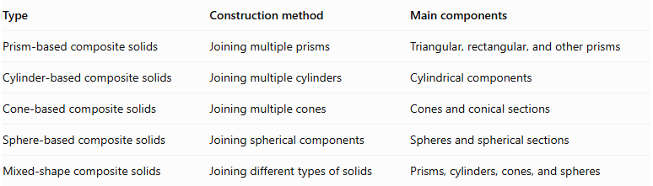
Type | Construction method | Main components
Prism-based composite solids | Joining multiple prisms | Triangular, rectangular, and other prisms
Cylinder-based composite solids | Joining multiple cylinders | Cylindrical components
Cone-based composite solids | Joining multiple cones | Cones and conical sections
Sphere-based composite solids | Joining spherical components | Spheres and spherical sections
Mixed-shape composite solids | Joining different types of solids | Prisms, cylinders, cones, and spheres

Applications
# Source: AI Source: Provided by: [Data Path: Persons Table -> ID Column: 1, Name_En Column: Motasem Essam] -> From: [ChatGPT] on [7/25/2026]
- Mechanical engineering: Designing shafts, stepped cylinders, rollers, and cylindrical assemblies.
- Architecture: Designing cylindrical columns and structures with different cylindrical sections.
- Construction: Creating cylindrical supports, pillars, and structural components.
- Manufacturing: Producing cylindrical parts with multiple diameters and lengths.
- Product design: Creating cylindrical housings, containers, and mechanical components.
- Computer-aided design (CAD): Modeling complex cylindrical structures through geometric combination.

Key Points
# Source: AI Source: Provided by: [Data Path: Persons Table -> ID Column: 1, Name_En Column: Motasem Essam] -> From: [ChatGPT] on [7/25/2026]
- Cylinder-based composite solids are formed by joining two or more cylindrical components.
- Cylinders may have identical or different dimensions.
- Common arrangements include coaxial, stacked, end-to-end, parallel, radial, and intersecting configurations.
- Their total volume is calculated by adding the volumes of their cylindrical components, accounting for overlaps.
- Their external surface area includes only exposed surfaces.
- Internal contact surfaces must be excluded from external surface area calculations.
- They are widely used in mechanical engineering, architecture, manufacturing, and CAD.

Conclusion
# Source: AI Source: Provided by: [Data Path: Persons Table -> ID Column: 1, Name_En Column: Motasem Essam] -> From: [ChatGPT] on [7/25/2026]
Cylinder-based composite solids are three-dimensional geometric objects formed by joining multiple cylindrical components into a single structure. Their components may have different radii, heights, and spatial arrangements, producing simple or complex cylindrical configurations. Understanding their geometric construction and mathematical properties provides a foundation for calculating their total volume and external surface area and analyzing practical cylindrical structures.

